Development of a New Innovative Concept of Ropax Ship

Dundara Djani (ULJANIK), Pula, CROATIA djani.dundara@uljanik.hr
Bocchetti Dario (Grimaldi),Napoli, ITALY, bocchetti.dario@grimaldi.napoli.it
Kuzmanovic Obrad. (ULJANIK), Pula, CROATIA obrad.kuzmanovic@uljanik.hr
Zanic Vedran, University of Zagreb, Zagreb, CROATIA, vedran.zanic@fsb.hr
Andric Jerolim, University of Zagreb, Zagreb, CROATIA , jerolim.andric@fsb.hr
Prebeg Pero, University of Zagreb, Zagreb, CROATIA, pero.prebeg@fsb.hr

Abstract

This paper relates to the development of a new innovative concept of RoPax ship at the IT environment of ULJANIK Shipyard, Pula, CROATIA. This work is performed within the framework of the EU FP6 IMPROVE project and includes two levels of concept design: general and structural. The primary design focus is the general ship design preformed by ULJANIK cascade of various design oriented analyses tools for the first design loop (resistance/stability/operability). Comparisons of selected design variants are given, including large savings due to novel propulsion concept. Second part of the paper briefly presents the design methodology necessary to perform extensive multi-objective structural optimization of RoPax structure using the extended OCTOPUS-MAESTRO software. It performs multi-objective optimization, (minimum cost/minimum weight/maximum safety measures/etc.) while satisfying structural constraints: yielding, buckling, displacements and ultimate strength of hull girder and ship panels.

1. Introduction (UZ+ULJ)
The main objective of the IMPROVE project is to design 3 different types of next generation vessels by integrating different aspects of ship structural design into one formal framework and applying it. The nature of shipbuilding in Europe is to build small series of very specialized ships (the opposite of the Korean and Chinese shipyards). Thus, the IMPROVE project will address ships which, with their complex structures and design criteria, are at the top of the list for customization. The IMPROVE consortium has identified the next generation of Large ROPAX ship, Product/chemical carrier and LNG gas carrier as the vessels the most suitable for European yards to focus their energies on.
ULJANIK Shipyard in the last 5 years has designed several car-carriers, ConRo and ROPAX vessels for different ship-owners (Zanic, Sponza, Dundara et al, 2001, Zanic 2001 and 2007). For a long period ULJANIK has strong cooperation with GRIMALDI GROUP as respectable ship owner regarding market needs and trends.
For new design extensive structural analysis (global and detail FE analysis) are performed to evaluate global structural feasibility and eliminate hard spots regarding stress concentrations problem (see figure e).
The arrangement of cargo space without pillars requests sophisticated structure solutions. Reducing height of deck structure is a very demanding task and can result in many benefits regarding general ship design, e.g.:
- Lower VCG (better stability).
- Reduced light ship weight (increased deadweight)
- Smaller Gross Tonnage
The challenge is to improve Rule structural design at the early stage of design (concept stage) and to find optimal design solution with the IMPROVE tools and continue the design process in preliminary stage (where more detailed FEM calculations are performed) with the better starting point/design. Decrease of production cost (optimum sequence of production for ULJANIK environment) is the relevant design objective.
Regarding general ship design the other targets are:
- Selection of resistance friendly hull form
- Smaller propulsion engine for same speed
- Reduced fuel oil consumption
- Selection of hull form in order to reduce length of engine room (increased length of cargo space)
The objectives in the multi-criteria decision making process will be considered using rational models:
- to assess sea keeping and manoeuvring performances,
- to assess design loads and accidental loads at the early design stage.
- to assess fatigue at the early design stage,
- for assessment of ultimate strength at the early design stage,
- to assess vibrations at the early design stage,
To achieve defined objectives an existing line of vessels, as designed by ULJANIK shipyard and GRIMALDI GROUP, will be re-assessed (structural limit states, production cost, maintenance assessment) with IMPROVE.. This will help to tune the new tools/procedures within ULJANIK and GRIMALDI design/maintenance environments for the tasks of new ROPAX design.

2 General Ship Design

2.1 Tools involved in the general ship design

2.1.1 TRIDENT system
TRIDENT is a fully integrated CAD/CAM solution based on PTC® CADDS®5i product database developed in Uljanik Shipbuilding Computer Systems (USCS). It works under CADDS®5i environment and uses other CADDS®5i subsystems to cover areas such as mechanical design, etc. It has all advantages of CADDS®5i environment (full interactive, 3D, modern user interface, subsystems integrated in the same data bases), and it integrates all project and construction activities.
The layout of TRIDENT modules and their relations to the CADDS®5i database are shown below.

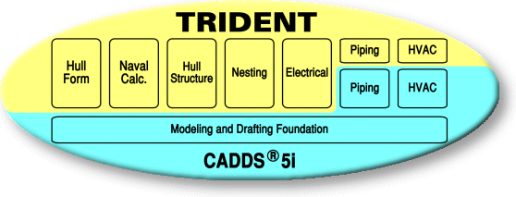
Figure 1. TRIDENT
The Hull Form and Naval Calculation modules cover the initial phase of the ship hull design process. They are used to determine all main characteristics of a future ship.
The Hull Form module functionalities are:
- Hull form modeling from a sketch or by variation from the archive of forms
- Tools for fairing curves and surfaces based on shipbuilding experience
- Transformation of existing hull forms to meet the required L, B, T, displacement or LCB
- Calculation of basic form properties (displacement, KM, VCB, LCB)
- Extended features for creation and modification of the hull form with NURBS curves
- Surface patches creation with NURBS curves mesh
- Automatic generation of building frames
- Hull form details definition (e.g. mooring equipment, rudder, etc.).
- Intersection of hull form with arbitrary planes to obtain frame lines, waterlines, etc.
The Naval Calculations module lets the designers perform the necessary naval and geometrical calculations based on a hull created by the Hull Form module:
- Calculations based on HULL FORM module (hydrostatics, intact stability, floodable length, launching, tonnage, Bon-Jean data)
- Geometric calculations for compartments (capacity, sounding and ullage tables, grainshifting moment)
- Damage stability calculations
- Loading conditions
- Ship resistance calculations
- Integration of CADDS 5i and SEAKING data bases
More information can be found at http://www.uscs.hr/products.htm.

2.2. Uljanik General Design Procedure
The diagram presented in Figure 2 describes the design procedure for the ROPAX product. The data flows between specific activities are shown. The part of data flow between activities inside the CADDS/TRIDENT environment is fully integrated. All data are transferred in electronic format, so for the next activities the designer should only add the new data set needed for specific activity.
Besides the CADDS/TRIDENT, ULJANIK (USCS) uses several external applications, such as MARS 2000 for the calculation and dimensioning of the mid ship section, NAPA STEEL for the compartments definition and OCTOPUS/MAESTRO for the FEM analysis and optimization of the hull structure. Diagram description:
- The design process starts with the ship owner enquiry, which defines the main ship parameters, from dimensions, capacity, range of navigation, maximum speed etc.
- From the database of existing hull forms, the appropriate form is chosen. Based on it, the calculation and optimization of the ship’s main dimensions are performed. The processing is done with a program module inside the CADDS/TRIDENT environment, which calculates the needed power of the main engine and the estimated speed, taking into account the given range of parameters. Based on these results, a narrower range is selected and its metacentric height is estimated, which leads to the most appropriate final solution.
- According to the selected dimensions and given loads, the transverse strength primary elements are dimensioned in order to get the minimum ship height up to the strength deck.
- The affine form variation and hull fairing of the selected form is performed (inside the CADDS/TRIDENT environment), and it is the base for all following activities. Each change in the hull form implies the repetition and redefinition of the following activities.
- The General Arrangement plan and the Engine room arrangement plan are generated (inside the CADDS/TRIDENT environment).
- The mid ship section is defined and dimensioned according to the Classification society requirements using the program MARS 2000.
- The dimensions calculated with MARS can be analyzed and optimized with FEM tools (OCTOPUS/MAESTRO), but the rough 3D model of the ship structure has to be generated in order to have the correct data for the Centre of gravity and the Light ship weight. (CADDS/TRIDENT environment).
- The compartment definition can be done either by using NAPA software or by modules inside the CADDS/TRIDENT environment. Data concerning the hull form are transferred to NAPA via IGES format, and the same format is used to transfer data about the compartments to TRIDENT. Some post processing of transferred data is needed (e.g. control of data and, in certain cases, some manual correction).
- All the performed naval calculations are based on the Capacity plan, the Damage waterlines calculation being the most relevant for ROPAX product.

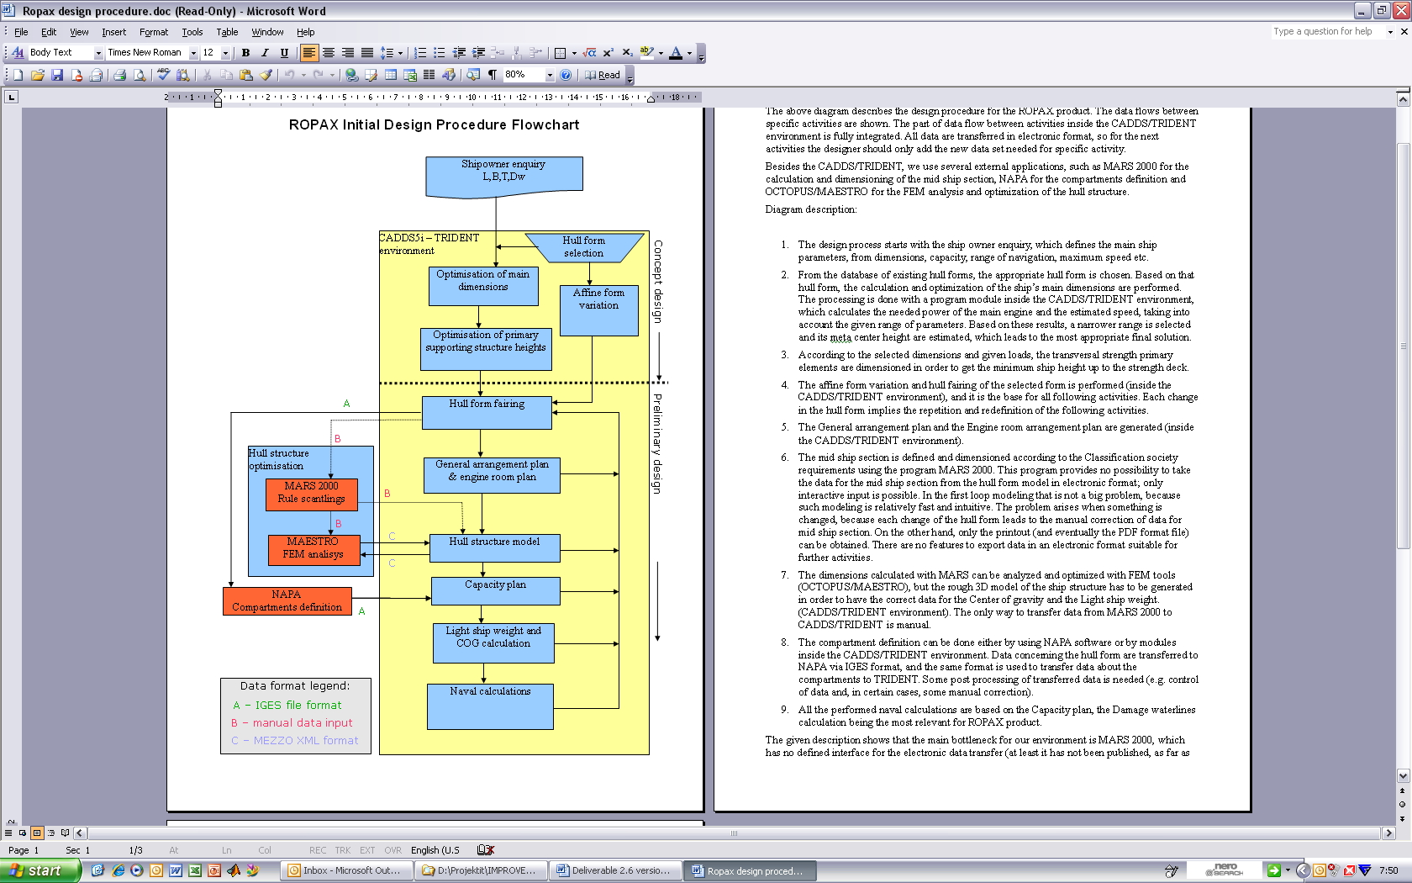
Figure 2. ROPAX Initial Design Procedure Flowchart

2.3 General concept design of ROPAX
The design methodology in the IMPROVE project defines three design levels:
- STANDARD SHIP is the existing ship or Yard prototype
- NEW SHIP will be designed during the first period of the project. The design will be realized using mainly the existing methodology and will include improvements to the main dimensions, general arrangement, hydrodynamics and propulsion
- IMPROVE PROJECT SHIP will be obtained from Level 2 design using multicriterial structural optimization including the production and maintenance models
The project of ROPAX, recently analyzed by ULJANIK, will be considered as standard ship, Fig.3.
Fig 3. Standard ship
The main characteristics of this ship are given below.
- Main dimensions: Length overall – 193 + 4 m, Breadth – 29.8 m, Draft design – 7.5 m
- Trial speed – 24.5 knots
- Cargo capacities – Trailers 3000 lane meters + 300 cars
- Capacities: HFO – 1400 m³, DO – 250 t, FW – 1200 m³, SW – 600 m³
- Passengers: 350 cabins + 200 aircraft seats
- Crew 200 persons
This design was developed in cooperation with Siemens Schottel and Sea Trade from Oslo. The designed ship had to be propelled by two pods behind two skegs.
Main dimensions of ROPAX concept design are optimized using TRIDENT/SEAKING software (USCS software, see http://www.uscs.hr) in order to obtain minimal main engine power and sufficient stability. A new application was developed, which finds a best combination of main dimensions in order of minimal resistance. After resistance calculation, it was decided that new ROPAX will have fixed pitch propeller (FPP) as main, and active rudder as auxiliary propulsion. Auxiliary propeller is driven by direct electric drive of 5000 kW using bevel gears at the top and the bottom of the leg (inside circular torpedo body). Planetary gears for steering are driven by frequency controlled electric motors. Original hull form was Uljanik's biggest PCTC, which was then transformed into new (level 2) form (see Fig 4). In comparison with standard ship, new design needs almost 7000 kW less power, weight of machinery is reduced by 450 t, fuel oil consumption is 28% less and finally, propulsion system is more reliable. Index of redundancy is 100% (2 independent engine room, 2 engines, 2 independent propulsion systems).
Main characteristics of a new ship:
- Length overall abt 193 m • Length between perpendiculars 180 m
- Breadth 29.8 m • Design draft 7.5 m
- Block coeff. 0.53 • Trial speed 24.5 kn
- Main engine power (MCR) 14940 kW • Active rudder output 5000 kW
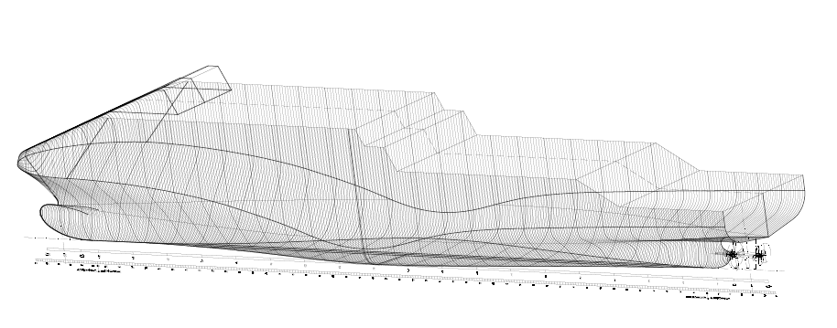
Fig. 4 Body Lines of New Ship
Loading/unloading of vehicles is done via stern ramp over four decks. Trucks and trailers are parked on tank top, freeboard deck and upper deck, while cars and smaller vehicles are located on second deck. The total lane length is 3000 m plus 300 cars. There are two fixed ramp ways for transport connection between decks, one going from tank top to main deck with bridge extension to second deck and the other form main to upper deck, see Fig.5.
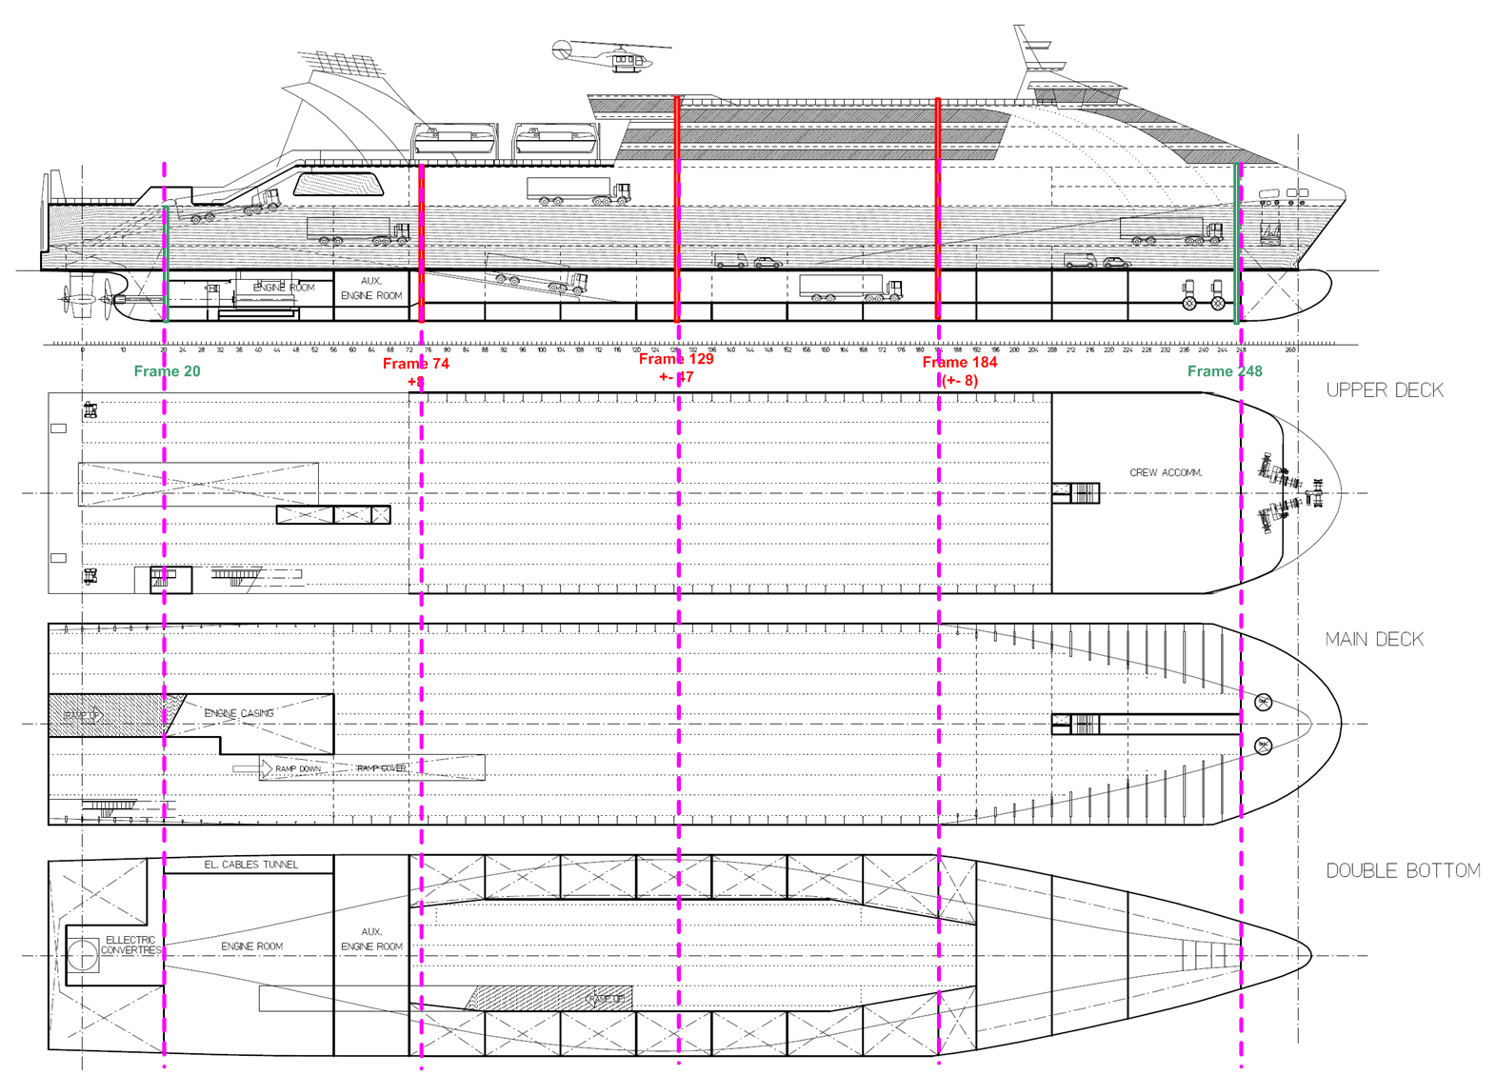
Fig 5. General Arrangement with marked specific positions (characteristic sub-sections at Frs. 74, 129 and 184) influencing ship zones 1-3
Passenger embarkment is done also via stern ramp over elevators to accommodation decks with capacity of 1400 passengers in 350 cabins and 200 aircraft seats. There are also various service and entertainment facilities. The accommodation of 200 crew members is in cabins above upper deck in fore part abaft mooring space and also abaft navigating bridge. Engine room space is divided into three parts: main engine room with main engine with power of 14900 kW, auxiliary engine room with 4 engines with total power of about 9000 kW and electric converters room for driving active rudder propeller.
The concept design of ROPAX ship (first loop of design) was described in previous sections. The project is in model integration phase now (IMPROWE WP5), so the most important tasks, development of new products are forthcoming. The expected most important design goals , in respect to level 2 ship, are: 4% less lightship mass, 8% more lane meters on tank top, 9.5% less power requirements, 3.5% less machinery mass, 4.5% less fuel oil consumption, 5-10% less cost of maintenance, 10-15% more operational efficiency, 8% less production cost, 11% less lead time.

3 Ship Structural Design

3.1 Tools involved in the ship structural design
The ROPAX structural design process requires number of tools like MARS, HYDROSTAR, MAESTRO and COSMOS tools, but the OCTOPUS Framework is the key tool. OCTOPUS is an integrated ship structural modeling, analysis, and optimization system for the concept design phase (Zanic et al 1993-2007)
The general mathematical model for a structural design contains the analysis and the synthesis modules. They have been developed and implemented in the decision support systems MAESTRO (2006) and OCTOPUS (2006). They can be decomposed, in principle, into six meta-systems of which two basic ones (Φ, ε) provide physical and environmental definitions of the problem / process and other four are behavioral systems (ρ, α, π, Ω) for modeling response, adequacy, reliability and quality. They are invoked into the design problem definition modules (Δ) and coupled with different optimization solvers (Σ) into multi-attribute multi-level synthesis procedure. The OCTOPUS hybrid problem sequencer permits flexible and interactive control of decision-making process for the hierarchically structured concept design system. Table 1 summarizes the analysis modules for all meta-systems.

3.1.1 OCTOPUS ANALYSER
OCTOPUS model (2.5D FEM) is generated on the basis of one bay model produced manually using the MAESTRO Modeler software MAESTRO (2006) and/or by automated CAD to FEM data transfer using TRIDENT software, (OCTOPUS, 2006). It can be used for fast concept exploration on the midship section level and is a rapid first step to the final determination of the structural scantlings using MAESTRO
OCTOPUS RoPax model (2.5D FEM) is generated on the basis of one bay model produced interactively using the MAESTRO Modeler software. Figure 6 shows OCTOPUS 2.5D FEM structural models of RoPax at midship section three characteristic zones (Fr. 76, Amidships, Fr. 184)

3.1.2 MAESTRO
MAESTRO is an integrated ship structural modeling, analysis, and optimization system for the preliminary design phase. It is also applied in concept design phase for generic 3D models. It combines rapid ship-oriented structural modeling, large scale global and fine mesh 3D finite element analysis, structural failure evaluation, and structural optimization.
The characteristics/modules of MAESTRO that are selected for RoPax problem are summarized in Table 1. Figure 7 shows MAESTRO 3D FEM partial structural model of RoPax.

Table 1: Implemented analysis modules for structural design
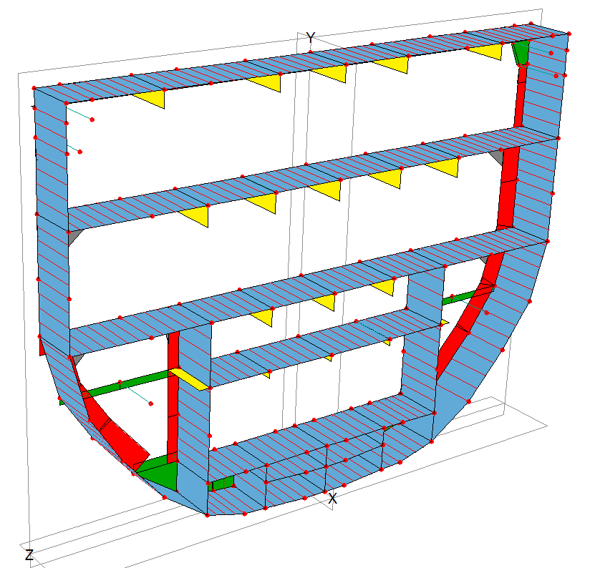  Section at Fr.76 | 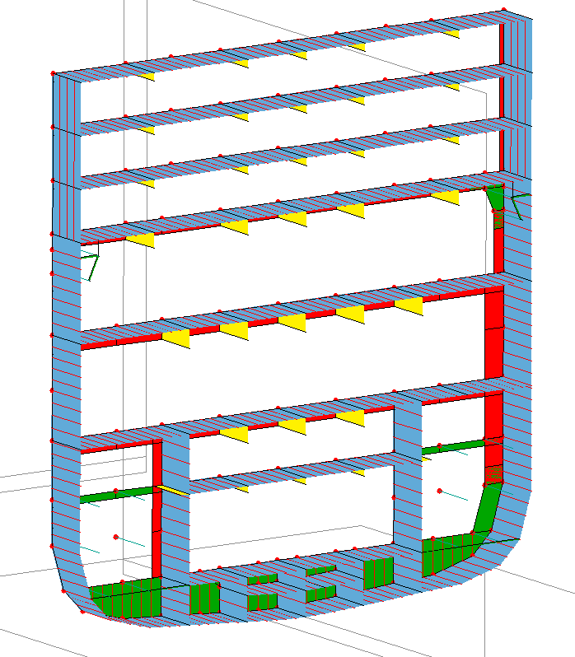  Section at Fr.129 | 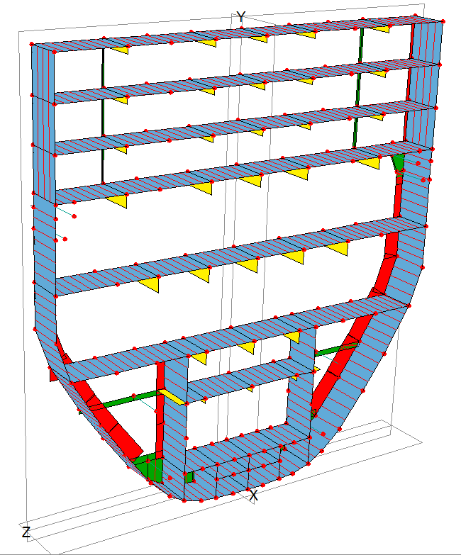  Section at Fr.184
Figure 6. OCTOPUS models of RoPax in ship zones 1, 2 and 3
Figure 7. Partial MAESTRO 3D FEM of RoPax

3.1.3 OCTOPUS DESIGNER
In this section OCTOPUS DESIGNER, framework for the decision support problem manipulation with components DeMak (Δ and Σ modules) and DeView (Visualization Γ modules), will be presented. The work on DeMak started back in 1990 [6], but recently it has been redefined to enable easy implementation of all new developments, together with the flexible graphical user interface which enables easy problem definition and problem solving. The visualization of the output and the final design selection are transferred to the DeView tool.
a)  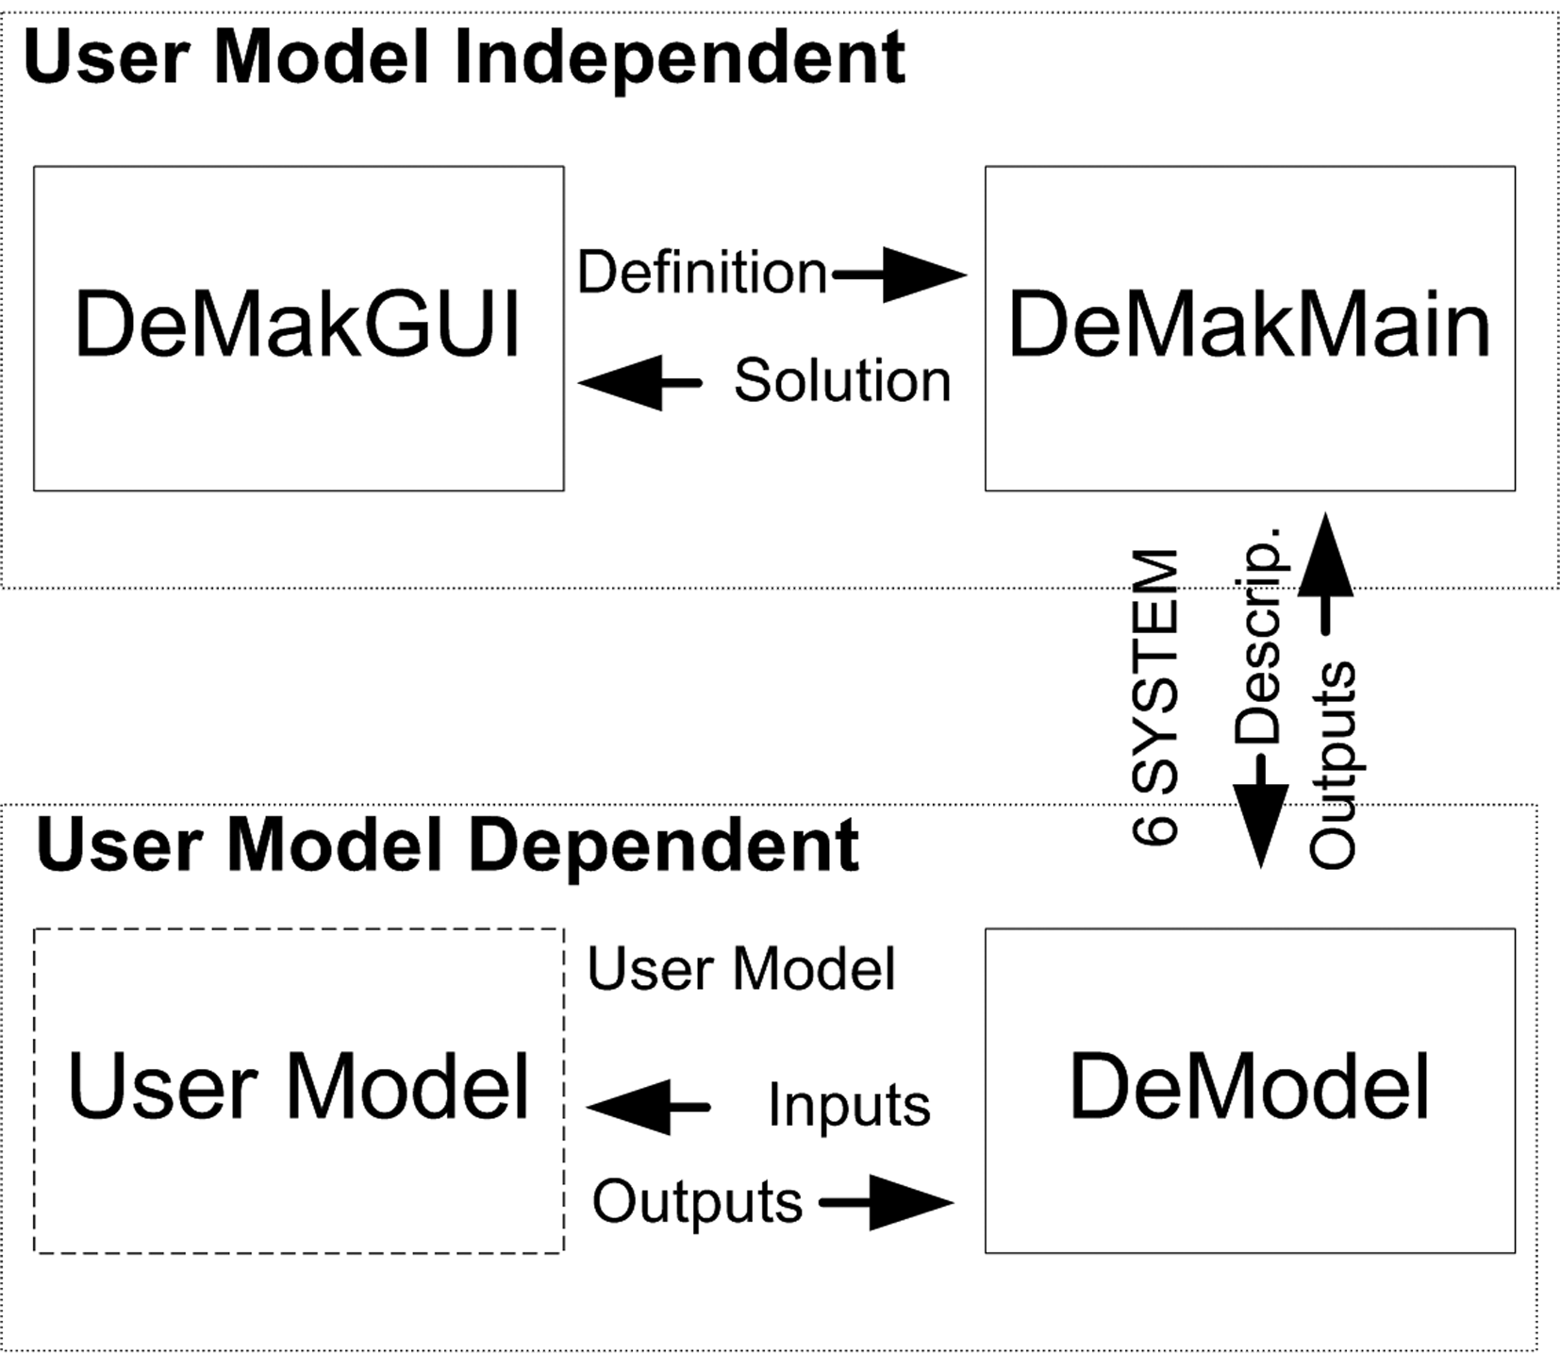 | b)  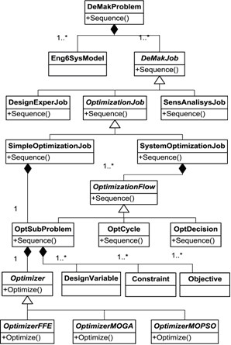
c)
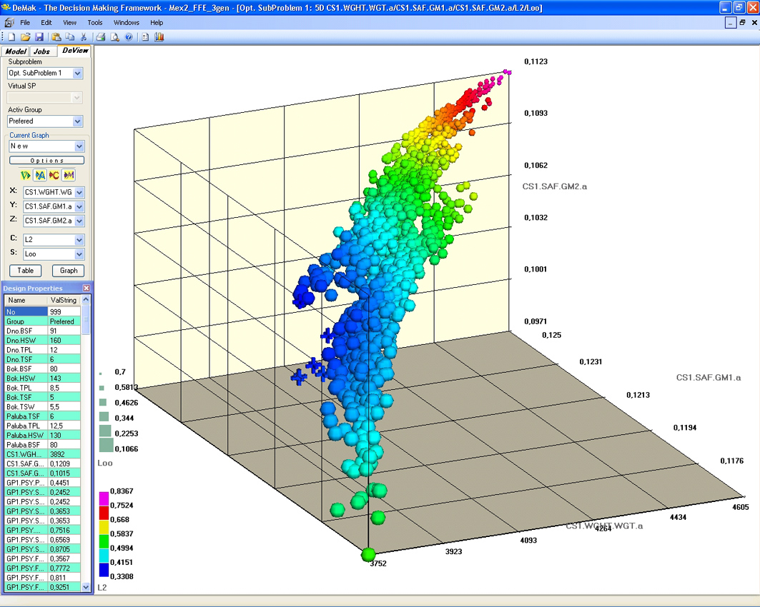
Figure 8. a) OCTOPUS DESIGNER components diagram b) DeMakMain class diagram,
c) visualization of Pareto designs in 5D space
The whole framework is programmed in VS2005 in .NET technology using several computer languages (C#, FORTRAN and C++).
Figure 8a) shows diagram of the OCTOPUS DESIGNER components and their interaction. It is important to notice that DeMakGUI and DeMakMain are problem (model) independent. DeModel component wraps User Model component (e.g. OCTOPUS ANALYSER for structural problems) and gives prescribed interface for up to 6 Engineering Systems. This enables communication between User Model and User Model Independent components.
Figure 8b) shows the UML class diagram of the fundamental classes in DeMakMain. On the top is the DeMakProblem class which contains all jobs (DeMakJob) which the designer has to perform during design of a certain model (Eng6SysModel).
Eng6SysModel class represents general engineering model with e.g. 6 elementary meta-systems as given in Table 1 for the structural analysis model.
DeMakJob class is abstract, which means that it only defines some common members and the interface which each derived class has to satisfy. Under the premise that the designer will generally perform three types of jobs, they are defined and designated as: DesignExperimentsJob, SensitivityAnalysisJob and OptimizationJob.
DesignExperimentsJob class defines all fields and methods needed to perform some design experiments and which can be used to reveal some relationships in the user model. It is also useful to perform it prior to the definition of optimization problem, because it can reveal that certain parameters do not significantly influence the criteria, and therefore there is no need to define them as design variables. This reduces dimensionality of the problem.
SensitivityAnalysisJob class enables execution of sensitivity analysis to assess stability of certain design, or else to point to some possible errors in a particular user model (often used in FEM).
The last type of job is DeMakOptimizationJob. Again, it is defined by abstract class because there are generally two types of actual optimization jobs: SimpleOptimizationJob and SystemOptimizationJob.
SimpleOptimizationJob is intended for simple optimizations without decompositions and hybrid solvers. Basically it contains one instance of OptimizationSubProblem class as explained later.
SystemOptimizationJob class contains definition of all fields and methods necessary to enable optimization of real world problems which demand decomposition, hybrid solvers and some advanced logic. This is accomplished by encompassing collection of OptimizationFlow objects which define some processes during the complex optimization.
OptimizationFlow class is the abstract base class for the following derived classes: OptimizationSubProblem, OptimizationCycle and OptimizationDecision. Those classes generally control execution of OptimizationJob Sequence.
OptimizationSubProblem class is fundamental to the optimization because it contains all components necessary for optimization: design variables, constraints, objectives and optimization algorithm which will generate nondominated designs.
Abstract class Optimizer shares the definition of optimization components (design variables, constraints, objectives) with OptimizationSubProblem and also defines interfaces that each derived class, or actual optimization algorithm, has to satisfy. Easy implementation of the third party optimization algorithm components is thus enabled. Optimizer also specifies that the output is set of non-dominated designs with all the information which defines specific design (the particular values of variables, attributes and constraints).
Currently five optimization algorithms are included in OCTOPUS:
- Sequential Linear Programming (SLP) ,
- Monte Carlo based Evolution Strategies (ES-MC)
- Fractional Factorial Experiments based Evolution Strategies (ES-FFE)
- Multi Objective Genetic Algorithms (MOGA),
- Multi Objective Particle Swarm Optimization (MOPSO).
DeMak graphical user interface (GUI) enables designer's flexible communication with DeMakMain component in the form of interactive input definitions (Δ) and output visualizations (Γ). The screenshot of the graphic user interface with the navigation panel on the left and the optimization job main input panel on the right are shown in Figure 9.

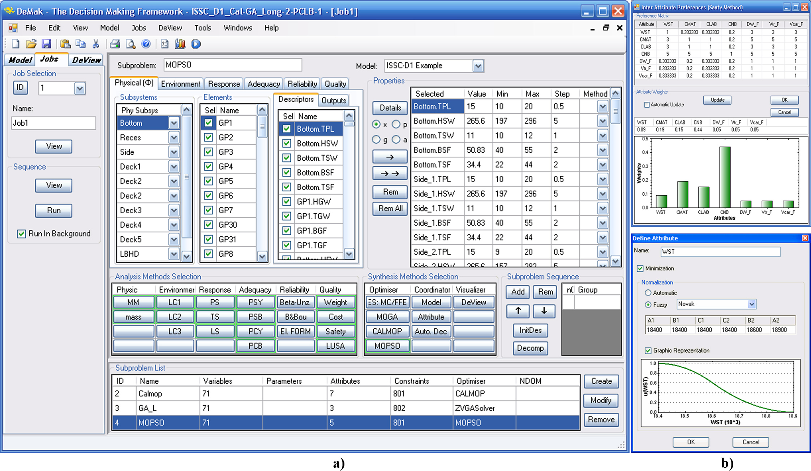
Figure 9: DeMak screenshot (a) Optimization job main input panel (b) Definition of inter (up) / intra (down) attribute preferences
The main optimization job definition panel is assembled from three panels.
Upper panel serves for the selection of design variables, attributes/objectives and constraints from given Descriptors and Outputs in engineering meta-systems for selected OptimizationSubProblem.
The left part of the middle panel is used for the selection of analysis methods which will be used during the execution of the selected OptimizationSubProblem, while the right part is used for the selection of synthesis methods.
The bottom panel is used for creation, deletion and selection of current OptimizationSubProblem.
In the Γ modules the designer has a possibility to change his/her subjective decisions during design process by using interactive panels for a definition of inter attribute preferences (Figure 4b upper part), intra attribute preferences (Figure 4b lower part) or selection of the most convenient distance norm L_{p}. Those decisions can be made before or after the generation of Pareto designs, because the designer can change his preferences during the design process.
The last of DeMak GUI (Γ) modules is DeView tool which serves for visualization of design and attribute space. There are three means to visualize nondominated designs in DeView: 5D space, table view with statistics and the parallel axis plot of preferred designs.
In 5D space it is possible to visualize 5 design components at the same time (three on the 3D axes, one with the color and one with the size). It is also possible to mark some designs with different body types which can even give the 6th dimension. Figure 8c) shows the Pareto frontier for one solved problem where each sphere represents one Pareto design. In that space it is possible to interactively get properties of the selected design, or to add the design to some group of preferred designs.

3.2 ROPAX Structural Design
The ROPAX structural optimization concept is presented in Figure 10. The analysis requires MARS, HYDROSTAR, MAESTRO, OCTOPUS and COSMOS tools.
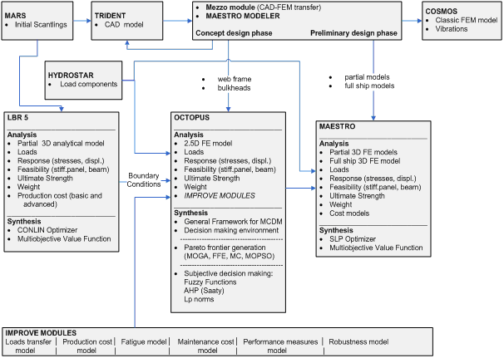
Figure 10: Overall structural design flowchart

3.3 Structural Design Methodology
For a structural design of RoPax product an efficient multi step procedure can be established to solve topology (and interwoven scantling/geometry) optimization. It consists of two main steps:
(1) topology / geometry optimization
(2) scantling / material optimization of the preferred variants from step (1).
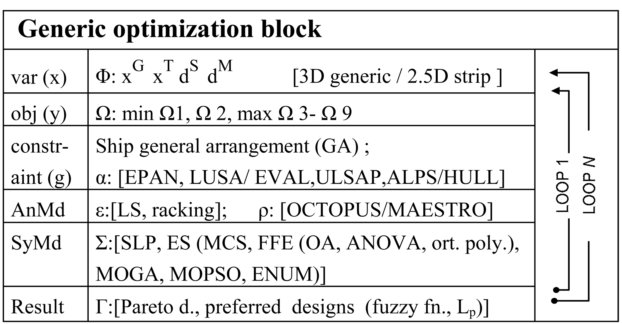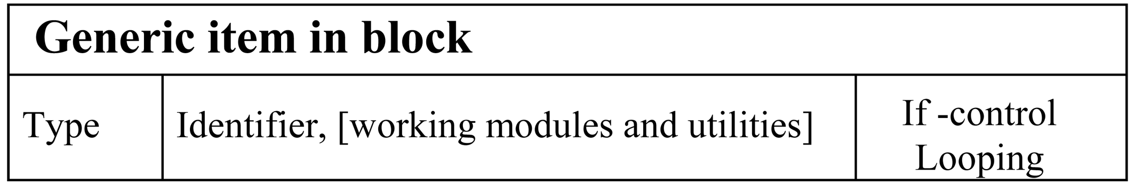
a) b)
Fig. 11: Design support problem a) decision making block, b) : item in decision making block
Each step includes a number of analysis and synthesis modules creating together the practical decision support environment. Each block is defined through max 6 items (rows in Fig. 11):
- Components of the design problem definition:
  - Variables x (usualy 2-600), are subset of total design descriptors d, subdivided into sub-sets:
x^{G}-geometry, x^{T} -topology, x^{S} -scantlings and x^{M}-material,
  - Attributes / objectives y (i=1, na, usualy 3-5),
  - Design constraints g (i=1, ng, usualy more than 10 000), ,
- Analysis modules (AnMd), described in more detail in Table 1,
- Synthesis modules (SyMd),
- Achieved results.
Each item contains (see Figure 11):
- Meta system identifier (e.g. Φ, Ω,.) and relevant parameters,
- Applied modules denoted with brackets [ ],
- If- control blocks,
- Loops of the design procedure.
The complete procedure is presented in Figure 12 through interconnected optimization blocks (a)-(f).
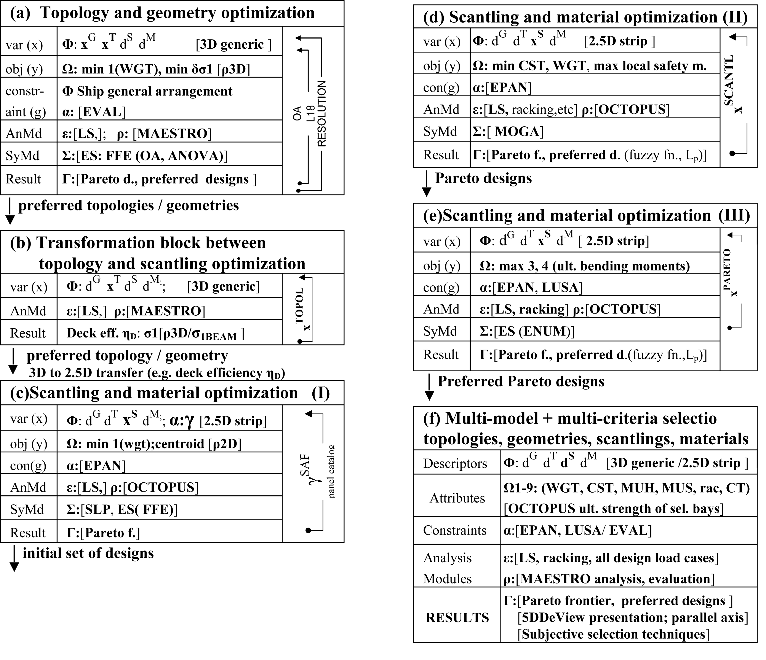
Fig. 12: Simplified design support problem sequence diagram for ROPAX
Step (1) of the concept design procedure for the multi-deck ships (containing topol-ogy and geometry optimization) is presented in the block (a) with the items used in Transformation block (b) is used as interface in the to-pology and scantlings optimization models.
Step (2) of the concept design procedure containing scantling and material optimization is presented in the blocks (c) to (e). Requirement on all of those blocks is computa-tional efficiency for e.g. reliability or ultimate strength nonlinear calculations.
Step (2) is divided into three phases:
- Phase I is used for fast MODM exploration of the design space and educated gen-eration of the initial population for Phase II.
- Phase II is the extensive scantling optimization with reduced analysis block.
- Phase III is the complete analysis of the reduced number of the preferred Pareto de-signs generated in Phase II.
Block (f) enables full application of the Decision Support Problem environment by the structural designer (see Figure 12a). The full analysis potentials of OCTOPUS and MAESTRO are applied. Subjective reasoning is performed through DeView modules and preference formulations in selection of the final design (see Figure 12b).

6. Conclusions
The first part of the paper has presented RoPax general ship design procedure preformed at ULJANIK (Naval Architecture calculations: speed, power, damage stability, etc.). For this purpose the computer programs were developed to facilitate selection of main ship parameters from the aspect of resistance, stability and operability. Corresponding comparison of selected design variants are given, including large savings due to novel propulsion concept.
Second part of the paper has presentted the design methodology necessary to perform extensive multi-objective structural optimization of RoPax structure at the early design stage using the OCTOPUS-MAESTRO software.

References
- Caprace J.D., Rigo Ph., Warnotte R., Le Viol S. : An analytical cost assessment module for the detailed design stage, COMPIT'2006, Edt. TUDelft, NL, 2006
- Rigo Ph. : Least-Cost Structural Optimization Oriented Preliminary Design, Journal of Ship Production, USA, 2001
- Rigo Ph. : An Integrated Software for Scantling Optimization and Least Production Cost, Ship Technology Research, Shiffahrts-Verslag “Hansa”, Hamburg, 2003
- OCTOPUS manuals FMENA, University of Zagreb, 2006.
- MAESTRO Version 8.7, “Program documentation”, Proteus Engineering, Stevensville, MD, USA
- Zanic, V., Das, P.K., Pu, Y. and Faulkner, D.: Multiple criteria synthesis techniques applied to reliability based design of SWATH ship structure, Integrity of Offshore Structures 5, Glasgow, pp. 387-415, 1993.
- Zanic, V., Jancijev, T., Trincas,. G., Nabergoj, R., Andric, J. : Structural Design Methodology for Large Roro/Passenger Ships, Journal of Ship and Ocean Technology, Vol 5, No.1, , pp.14-29, 2001.
- Zanic, V., Sponza, D., Dundara , Đ. Jancijev, T., Andric, J., Frank, D., Bralic, S :Racking Analysis of Car-Truck-Carriers, Brodogradnja, 49, pp. 181-190, 2001.
- Zanic V., Prebeg P. : Primary Response Assessment Method for Concept Design of Monotonous Thin-walled Structures, 4th Int. Conf. on Advanced Engineering Design, Glasgow, 2004
- Zanic, V.: Concept and Preliminary Structural Design Methods for the Modern Multi-Deck Ships, 2nd Int. Conference on Marine Research and Transportation, Naples, Italy, 2007.

Acknovledgments
Thanks are due to the support of the EU Commission for FP6 Project IMPROVE, Croatian Ministry of Science, Education and Sport: projects 0120-014 and TP-02/0120-23 and to all members of the IMPROVE team.

Appendix: ROPAX PROJECT REQUIREMENTS

A.1 DESIGN PROCESS REQUIREMENTS/OBJECTIVES FROM ULJANIK SHIPYARD:

• Area of navigation: Mediterranean (sea keeping analysis) // Large variations in season trade (summer 3000 pax, winter 100 pax)
• Hull form: Single hull // Superstructure made of steel or composite (no aluminium)
• Main dimensions: Up to the Max. length of slipway: ≈ 230m // Max. breadth: 30.40 m
• Engine selection and propulsion: Two stoke engines // Combined propulsion (screw + pods)
• Life cycle: Goal to minimize the maintenance cost // 25 years life time
// Probably conversion after 10 years due to new Rules or comfort standards (to be flexible and easy for conversion)
• Cargo handling: Traditional – stern door and internal ramps
• Seakeeping: No fin stabilizer but internal active stabilizer tanks
ULJANIK'S EXPECTATIONS FROM IMPROVE PROJECT:
Global goals: Reduced production cost 10 % // Reduced fuel oil consumptions 12 %
// Reduced maintenance cost 10 % // Increased lane metres on tank top 8 %

A.2 OWNER’S MAIN DESIGN REQUIREMENTS/OBJECTIVES
- Increase carrying capacity (lane meters) on tank top by decreasing the length of the engine room;
- Achieve load carrying flexibility;
- Improve the vessels’ operational performance and efficiency;
- Maximize the robustness of the required freight rate;
- Design for the redundancy and simplicity of systems;
- Increase ship’s manoeuvrability;
- Optimize the seakeeping performance for the Mediterranean Sea;
- Maximize comfort; // Minimize vibrations;

A.3 IMPROVE OBJECTIVES / TASKS FOR THE ROPAX CARRIER:
- Main dimensions should be optimised to improve the hydrodynamics
- New designs of stern part will be preformed to reduce length of the engine room and to increase cargo area (lane meters) on tank top
- Selection of slow speed main engine to improve maintenance and consumption
- Minimum height of deck transverses
- Improvement in design using existing and improved tools for early design phase :
- Rule calculation – simplified CAD model → simplified model (FEM, LBR5) → optimisation
- Minimum weight of freeboard deck transverses
- Minimum height of deck No3 and deck No4 transverses
- Accurate calculation at the early design stage of building tolerances and deformation constraints
- Superstructure decks effectiveness in the longitudinal strength to be considered
- Web frame spacing and longitudinals spacing, to be optimized
- Sea keeping and manoeuvrability
- Vibration of aft part
- Fatigue analysis
OBJECTIVES FOR PRODUCTION:
- Reduction of production costs, production simulation
- Reducing the number of different parts (standardization)
- Simplify production through the increase of subassembly work
- Less handling and assembly operation on slipway or block assembly area
- Reduce the amount of hull erection time on berth from 18 to 9 weeks (+3 for finishing)
- Reduce the number of erection blocks from 330 blocks (valid for the big car carriers) to 130 blocks – the design should be performed accordingly to that
- To reach the average of 2.8 erected blocks per day
- All the parts must be painted before erection
STRUCTURAL DESIGN OBJECTIVES:
- Maximize structural safety by means of maximizing global and local safety measures and maximizing structural robustness;
OPERATION, MAINTENANCE AND REPAIR OBJECTIVES:
- Minimize the lifecycle cost of the ship (it is the major goal for GRIMALDI). This should be achieved by minimizing the probability of potential repairs in the service time and by maximizing the maintainability of the ship.
THE MAIN DESIGN CONSTRAINTS:
- No pillars in cargo space;
- Satisfy Bureau Veritas and IMO rules.

