Third/Last Call, 25 May 2008

InfoDBlaS’08

I&CT International Conference
16-18 June 2008
Istanbul, Turkey

SEDEF Kalkavan Shipyard

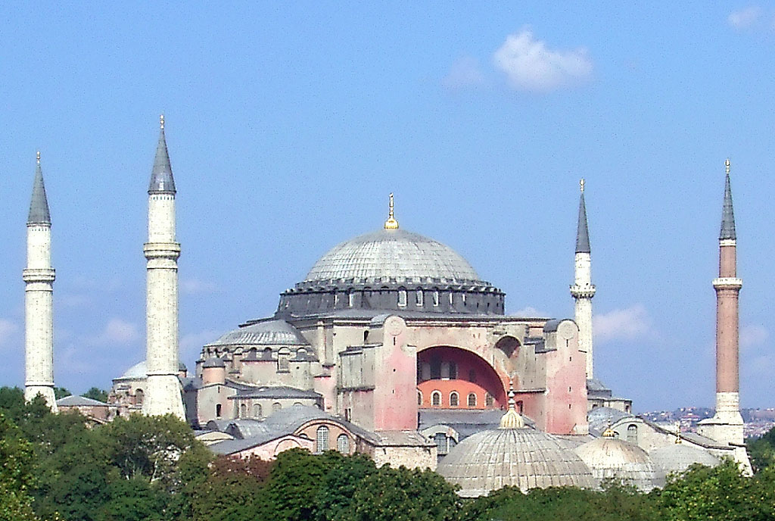

InfoDBlaS Project

International Black Sea Club (IBSC), is an organization of Cities-Ports from Black Sea Area as for example: Samsun, Trabzon (Turkey), Varna, Burgas (Bulgaria), Constanta, Galati (Romania), Ilichevk, Odessa, Youjnyi, Nikolaev, Kherson, Sevastopol, Yalta, Mariupol (Ukraine), Taganrog, Azov (Russia), Poti, Batumi, (Georgia), and other Cities-Ports interested in this area as: Piraeus, Thessalonica, Kavala (Greece), Izmit (Turkey) and Trieste (Italy),
IBSC founded in 1998 the so named Commission for Implementation and Development of Information and Communication Technology in Danube-Black Sea Area - InfoDBlaS (Informatics in Danube and Black Sea Area) to promote and develop the Information and Communication Technology (I&CT) in this area.

InfoDBlaS main applications and development directions:

- I&CT for Industrial Domains
(Shipbuilding and Plant Design PLM)

- I&CT for Public Administration

InfoDBlaS events (Yearly General Assemblies, Workshops, Conferences etc.) represented an important I&CT mutual collective contribution. We mention some of these events organized in: Galati (1999), Sebastopol (2000), Taganrog (2001), Izmit (2002), Varna (2003), Sebastopol (2004), Galati and Sebastopol (2005), Sebastopol 2006, Tulcea-Romania and Sebastopol (2007).

Starting 2005 it was decided that this International Conference must include also Danube Cities taking into consideration the close connection between Black Sea and Danube areas development. So that we plan to invite: Deggendorf, Nurenberg, Passau, Regensburg (Germany); Enns, Krems, Linz, Vienna (Austria); Bratislava, Komarno (Slovakia); Gyor, Vac, Budapest, Baja, (Hungary); Vukovar (Croatia); Novi Sad, Beograd, Smederevo, Kladovo, (Serbia); Vidin, Rousse (Bulgaria) Drobeta -Turnu Severin, Giurgiu, Oltenita, Braila, Tulcea, Sulina (Romania), Ismail (Ukraine)

Advisory Committee
Dr.Gelu KAHU, Chairman of InfoDBlaS, Executive General Director of Association Technopole Galati, Chairman of AVEVA Danube & Black Sea Area Reference Group………………... kahu_sdg@yahoo.com
Prof. Ahmet Dursun ALKAN, Yildiz Technical University Istanbul…ahmetdursunalkan@gmail.com
Tansel TIMUR, Chairman of Chamber of Turkish Naval Architects & Marine Engineers………………….. ………………………………………………………………………………………….ttimur@turkloydu.org
Radul KOVACHEV, IBSC Secretary General - Varna, ……………………………………. ibsc@tnt.bg
Cinar ATAOL, SEDEF Kalkavan Shipyard,……………….………… …cataol@kalkavanshipyard.com
Stephane NEUVEGLISE, AVEVA, Marine Manager Southern Europe........................ ....................... .........................................................................................................Stephane.Neuveglise@aveva.com
Ossi PIIPARINEN, AVEVA, Director-Marine Sales East Europe .............. ossi.piiparinen@aveva.com
Alexander PETROV, AVEVA, Sankt Petersburg................................. alexander.petrov@aveva.com
Mehmet TANKUT, ESRI Turkey…………………………....………. mtankut@esriturkey.com.tr

AGENDA (Third/Last Call, 25 May 2008)

Monday 16 June 2008

9.00 -10.00, Registration & Café (Conference fees payments, Conference folding distribution, Request for Conference - Bostanci Hotel Shuttle Bus, Request for Bus & Boat Istanbul City Tour on 18 June)

Opening Session

10.00 - 10.45, Welcome speeches from: IBSC Presidency, Mayor of the City of Istanbul representative, SEDEF Kalkavan, Turkish Chamber of Commerce and Industry, Yildiz Technical University Istanbul

10.45 - 11.15, Collective Photo
11.15 – 11.30, Café break

11.30 - 12.00, Key Paper O.1, InfoDBlaS’08, Tradition and Trends, Virtual Enterprise, Virtual City Hall, Dr.Gelu KAHU, Chairman of InfoDBlaS, Executive General Director of Association Technopole Galati, Chairman of AVEVA Danube & Black Sea Area Reference Group.

12.00 – 12.30, Key Paper O.2, Information and Communication Technology (I&CT) in Shipbuilding and Industrial Plants, New Achievements and Trends, Hans Van Der DRIFT, AVEVA Head of Central/Southern Europe region.

12.30 – 13.00, Key Paper O.3, Turkish Shipbuilding Industry,
Burak Omer SARACOGLU, Chamber of Turkish Naval Architects & Marine Engineers
13.00 - 14.00, Working Lunch

14.00 - 17.30 (16.00 -16.30 Café Break)
Session No.1, Workshops on Science and Technology in Industrial Domain , News and Trends
Chair: Dr.Gelu KAHU, Prof. Ahmet Dursun ALKAN
(Average duration of Paper presentations including discussions of participants abt.10-15 minutes)

Workshop 1.1. Applied Science and trends

Paper 1.1.1.Research, Development and Innovation for the Competitiveness of the Shipbuilding Industry, Prof. Ahmet Dursun ALKAN, Turkey
Paper 1.1.2. Vibration Calculations of Container Ships, Levent KAUDIHAN, Delta Marine, Turkey
Paper 1.1.3. The advantages of Geographic Information Systems (GIS) for Safety and Efficiency in Port and Waterway Management , Mehmet TANKUT, ESRI Turkey
Paper 1.1.4. IMPROVE - Design of Improved and Competitive Products, Stefan Giuglea, SHIP DESIGN GROUP Galati, Romania

Workshop 1.2. Innovative Technology and Management

Paper 1.2.1. The Challenge to Innovative Development, Dr.Gelu KAHU, Executive General Director of Association Technopole Galati
Paper 1.2.2. The Technical Information Portal, Stephane NEUVEGLISE, AVEVA France
Paper 1.2.3. ELO (Electronic Leitz Organizer), an Efficient Tool for Document Management, Claudiu BORSAN, ELO Romania, George Gabriel MOROIANU, RomLotuS, Romania
Paper 1.2.4. Project Workflow Management and Documents Management in Ship Design- Delta Marine Experience, Erki KIROGLU, Dept. Manager, Turkey
Paper 1.2.5, Multiplus, an ERP Environment for Industrial Domain, Product Structure and Application, Kare PETERSEN , Norway
Paper 1.2.6, Multiplus ERP, Klevens Shipyard experience, Inge-Jonny HIDE, Klevens Maritime Norway
Paper 1.2.7. Public Library a Tool for Large IT Promotion , Zanfir ILIE General Director of Galati Public Library V.A.Urechia

19.30 – 21.30, Social Event, Official Dinner

Tuesday 17 June 2008

9.00 - 12.30 (10.30-11.00 café-break)
Session No.2 “VIRTUAL ENTERPRISE”, Information and Communication Technology in Shipbuilding and Plant Design
Chair: Hans Van Der DRIFT, Stephane NEUVEGLISE, Cinar ATAOL
(Average duration of Paper presentations including discussions of participants abt.10-15 minutes)

Key Paper 2.1: “Virtual Enterprise” Concept. Hans Van Der DRIFT AVEVA Head of Central/Southern Europe region.
Paper 2.2. Starting with Design Activity how to Create a new Successful Business in Shipping Industry, ADMARIN Experience, Altan DEMIRSOYLU, General Manager ADMARINE, Turkey
Paper 2.3. Tribon to VM 12, Migration from Shipbuilding to Floating Structures, Ion STROE, General Manager, NASDIS, Romania
Paper 2.4.SEDEF Shipyard Continuous Developing New Tools, Serhat YILDIRIM, Chief of IT Department , SEDEF Shipyard Turkey
Paper 2.5. Linking a Design System with ERP Julien DE BEER, AVEVA
Paper 2.6.Data Asset Handover to the Life Cycle Portal, Julien DE BEER,

12.30 - 14.00 Working Lunch

14.00 – 16.30 (15.00-15.30 café-break)
“VIRTUAL ENTERPRISE”, Information and Communication Technology in Shipbuilding and Plant Design.(continuation):
Chair: Hans Van Der DRIFT, Dr.Gelu KAHU
(Average duration of Paper presentations including discussions of participants abt.10-15 minutes)

Paper 2.7. A New Challenge for SEDEF to design and build a 180.000 tdw Bulkcarrier, Cinar ATAOL, Chief CAD-CAM Dept.,SEDEF Shipyard Turkey.
Paper 2.8. Efficient Preparation of Piping Systems Working Drawings,
Yavuz Selim GUREL, CAD-CAM Dept, Tuzla Shipyard
Paper 2.9. The challenge of Working in a Global Environment Wilfried RITTER, Technical Director AVEVA, (30 Minutes),
Paper 2.10. CAD/CAM systems applications at “CHERNOMORETS” CDB, Anatoly PODPORIN
Paper 2.11. News in AVEVA Marine 12 (AM 12), Stephane NEUVEGLISE, AVEVA France
Paper 2.12. Demo for AM.12, Bahar ULUYOL, AVEVA Turkey

16.30-17.00, Conference Closing Ceremony

17.00 – 19.00 Visit SEDEF Kalkavan Shipyards facilities, Conference closing cocktail

Wednesday 18 June 2008

9.00 - 12.00, Optional, Istanbul City Tour

GENERAL REMARKS:
-The official language is English
- The interactive colloquial procedure will be used in order to assure the active involvement of participants. For this reason each paper will have at disposal for presentation and discussions an average duration of some 15 minutes.
- The papers to be in digital format in order to be inserted in Proceedings ISBN CD

CONFERENCE VENUE
The conference will take place in the SEDEF Kalkavan Shipyard, Tuzla Bay, Istanbul.

CONFERENCE REGISTRATION
You are asked to send to Conference organizers the Confirmation of your participation filling the annexed Participation Form writing the author and the title of your paper, to the Third/last dead line, as soon as possible but not late as 05 June 2008

The registration desks staffed throughout the conference are located in front of the
SEDEF Kalkavan Shipyard Conference room, open from 9.00 to 10.00 on Monday 16 June 2008 assure by separate desks/employees:

Desk No.1: Registration Conference, last confirmation of author and the title of your paper, Conference folding distribution,

Desk No.2: Conference fees payments,

Desk No.3: Request for Conference - Bostanci Hotel Shuttle Bus, Request for Bus & Boat Istanbul City Tour on 18 June,

Desk No.4: Café, Drinks and Turkish Delights.

CONFERENCE ORGANISERS (Contact Persons)
- Dr.Gelu KAHU, InfoDBlaS Chairman, Association Technopole Galati (ATG) Executive General Director, Chairman of AVEVA Danube & Black Sea Area Reference Group, kahu_sdg@yahoo.com
- Cinar ATAOL, SEDEF Kalkavan Shipyard, cataol@kalkavanshipyard.com

Third/Last Call, 25 May 2008

PARTICIPATION FORM

“InfoDBlaS ‘ 08”
Istanbul 16-18 June 2008

1. ORGANIZATION / COMPANY TITLE:
…………………………………………………………………………………………………
Address (Country, City, Street, No.):
………………………………………………………………………………………………….
Contact person: ………………………………..Phone …………………………………
Fax ………………………………………… E-mail ………………………………….

2. PARTICIPANTS NAME: ………… …………………………………………………….

……………………………………………………………….

Remark: If you will participate with more than 2 persons please copy this Form

- TYPE OF PARTICIPATION

 |  | Exhibition | Stand area (m²) |  |  | Stand outfitting
 |  | Conference paper
 |  | Device for presentation

Title of paper, Author, | Time | Speaker name

Upon filling return as soon as possible but not late 05 June 2008 (Third/ last Call deadline) as e-mail attach to:
Mr. Cinar ATAOL, cataol@kalkavanshipyard.com and copy to
Dr.Gelu KAHU, kahu_sdg@yahoo.com
Meeting’s fees: 100 Euro/person to be paid to InfoDBlaS, Association Tecnopole, desk, in Istanbul , by registration.
The fees include: Conference Proceedings (one ISBN CD copy for each participant/entity: Organization, Institution, Company etc.), Working Lunches, Official Dinner, Coffee, Logistic Facilities, Reserved Area for your I&CT exhibits (if any).
Personal Hotel reservation in conformity with your program
We recommend you the Hotel BOSTANCI in Istanbul, the nearest good hotel from SEDEF Kalkavan Shipyard, located in a nice commercial area (it was negotiated for SEDEF Guests especially good rates: 75 Euro for single and 98 Euro for double room, payable when you leave the hotel). The rooms will be allocated on a “first come first served” basis so please register directly to the Hotel early to avoid disappointment, asking the facilities for SEDEF.
Hotel Coordinates: pazarlama@thebostancihotel.com; phone: Tel:+90.216.362.48.48; fax: +90.216.372.60.00
. Address: Mehmet Sevkipasa Cad.No.20,Bostanci-Istanbul
Special Shuttle buses Hotel-SEDEF Shipyard connection for Conference participants assured by organizators against a reasonable price.
(You are under no obligation to stay at the recommended by us hotel and may make your own arrangements).

