PRE-BOOKING HOTELS IN SAINT-NAZAIRE
FOR ASSEMBLY GENERAL (15 and 16th March 2007)

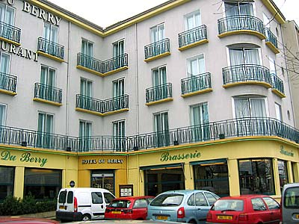

Le Berry*** (10 rooms)
Hôtel - Restaurant - Bar – Brasserie
1, place Pierre Semard
44600 SAINT-NAZAIRE
Phone : + 33.(0)2 40 22 42 61
Fax. : + 33 (0)2 40 22 45 34
Web : berry.hotel@wanadoo.fr

NOTE:

Hotel le Berry is near the station railway, at 10 mn by taxi from AKER YARDS Shipyard.

Korali** (15 rooms)
2, place de la gare

44600 SAINT-NAZAIRE

Phone : + 33 (0)2 40 01 89 89
Fax : + 33 (0)2 40 66 47 96

NOTE:

Hotel Korali is at 400 m to Hotel Le Berry, near the station railway, at 10 mn by taxi from AKER YARDS Shipyard.

LOCATION

