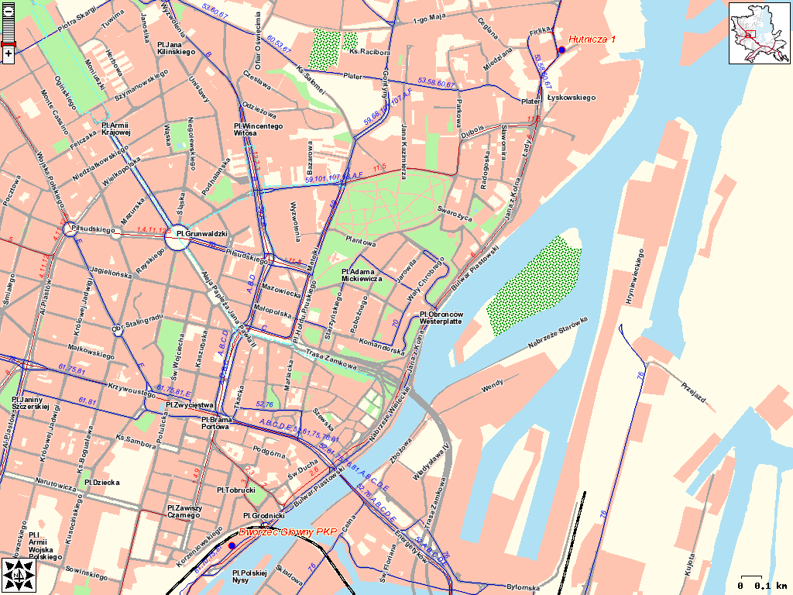
Dworzec Glowny PKP – this is the railway station
Hutnicza 1 – that’s where the meeting will be held

When you arrive at the train station, you can take either:

- a tram number 6 that goes to the shipyard. The stop is opposite to the main entrance. The tram goes directly to the shipyard – you need to get off at „Hutnicza” stop.
or
- a taxi to the hotel/shipyard.

